Armageddon Lab 1a

VPC Creation
First create VPC
VPC --> create VPC
-------------------------------------------------------------------------------
VPC Settings VPC and more
IPv4 CIDR block create the CIDR block you plan on using
IPv6 CIDR block and Tenancy should stay default
---------------------------------------------------------------------------------
Number of Availability Zones choose from 1| 2| 3
-----------------------------------------------------------------------------------
Number of public and private subnets choose from a number based on the number you choose for the AZ
Customize subnets CIDR blocks
Create the CIDR blocks for the public and private subnets
--------------------------------------------------------------------------------
NAT gateways leave as None
VPC endpoints choose None
----------------------------------------------------------------------------------
DNS options
Leave Enable DNS hostnames and DNS resolution both checked
-------------------------------------------------------------------------------------
Click on Create VPC

First create the Security Groups

EC2 Security Group

Security Groups Create security group
Basic details
Name it ec2-lab-sg
VPC
Choose the VPC you plan on using
Inbound rules
Type: HTTP
Protocol: TCP
Port: 80
Source: Anywhere IPv4 0.0.0.0/0
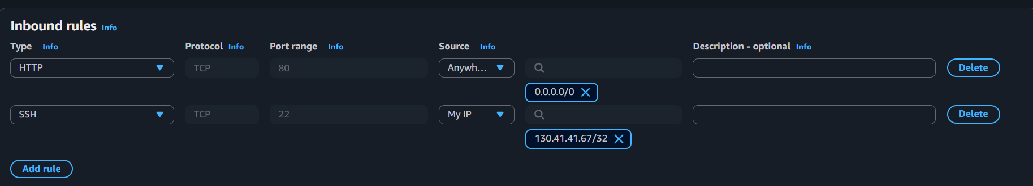
(Optional)
Type: SSH
Protocol: TCP
Port: 22
Source: My IP

Outbound rules
Leave alone
Click on create security group
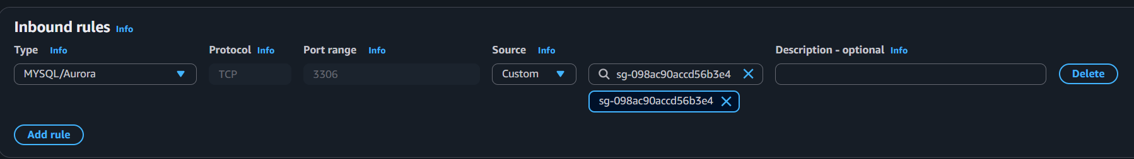

RDS Security Group
Basic details
Name it rds-lab-sg
VPC
Choose the VPC you plan on using
---------------------------------------------------------------------------------------------------------------------
Inbound rules
Type: MYSQL/Aurora
Protocol: TCP
Port: 3306
Source: Custom = ec2-lab-sg
---------------------------------------------------------------------------------------------------------------------
Outbound rules
Leave alone
Click on create security group

Create RDS Database
Go to Aurora and RDS subnet groups create DB subnet group
Subnet group details
Name: rds-subnet-group
Description: subnets for rds database
VPC: choose the vpc you plan on using

Add subnets
Availability Zones: choose the AZs you plan on using (I choose 3)
Subnets: choose the subnets (private)

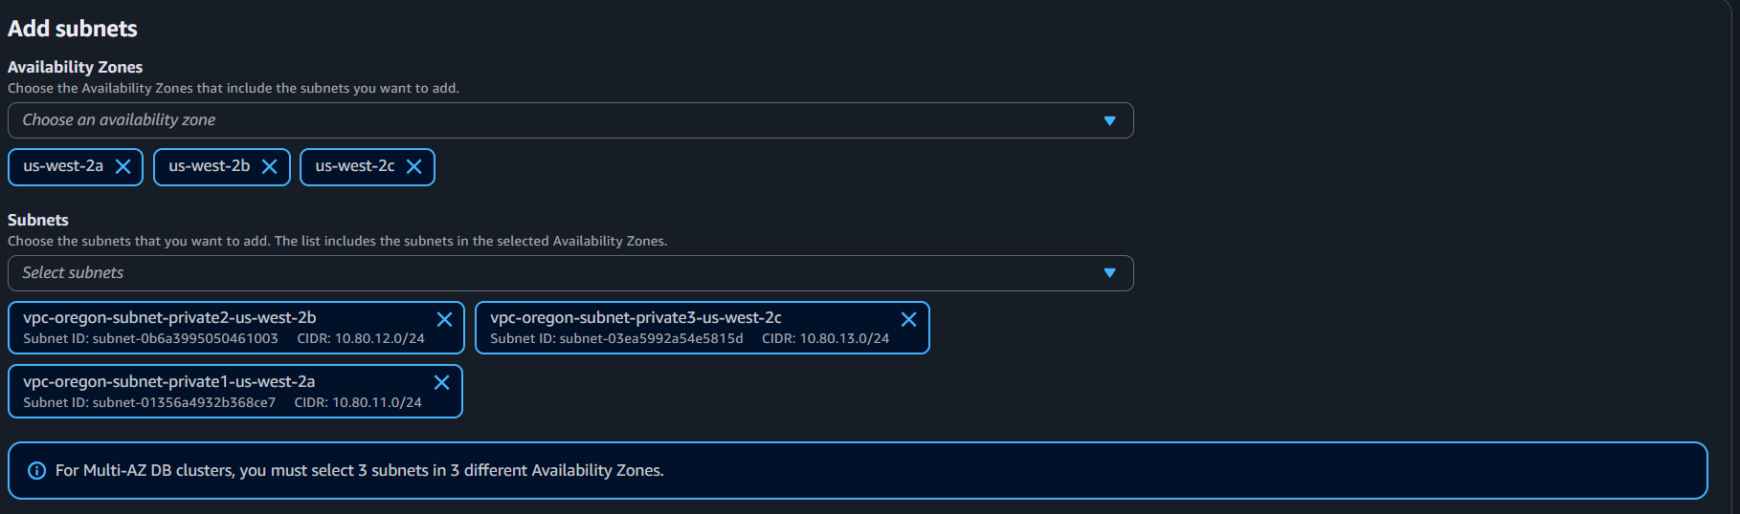
It will show the Subnets selected
Click Create
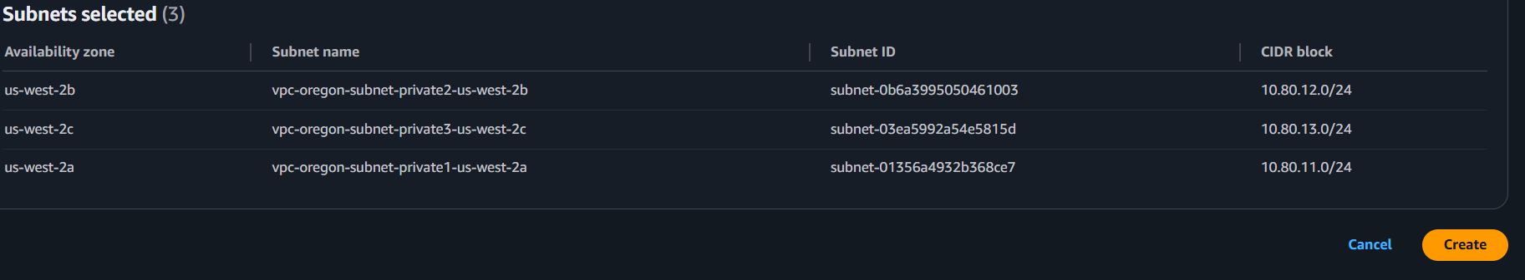

Databases create database
Choose a database creation method
Full Configuration
Engine options: MYSQL
Engine version: choose the latest version
---------------------------------------------------------------------------------------------------------------------
Templates
Free Tier
---------------------------------------------------------------------------------------------------------------------
Availability and durability
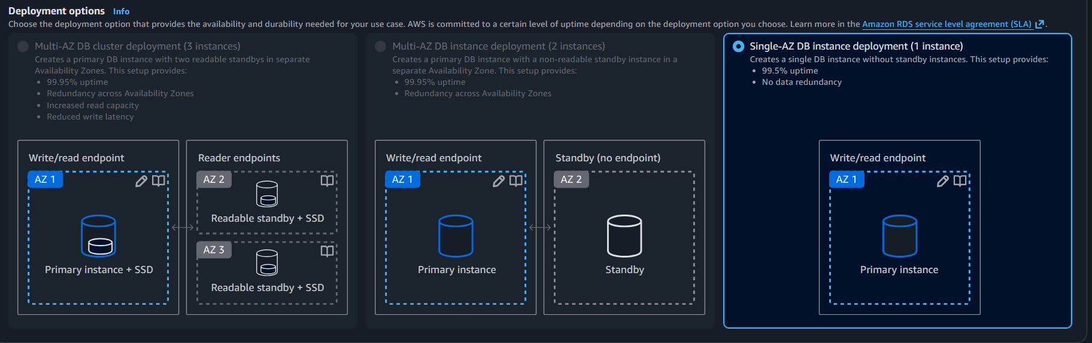

Settings
DB instance identifier: lab-mysql
Credentials Settings
Master username: admin
Credentials management
Choose either Managed by AWS Secret Manager or Self-Managed (if self-managed make sure to create a powerful password)
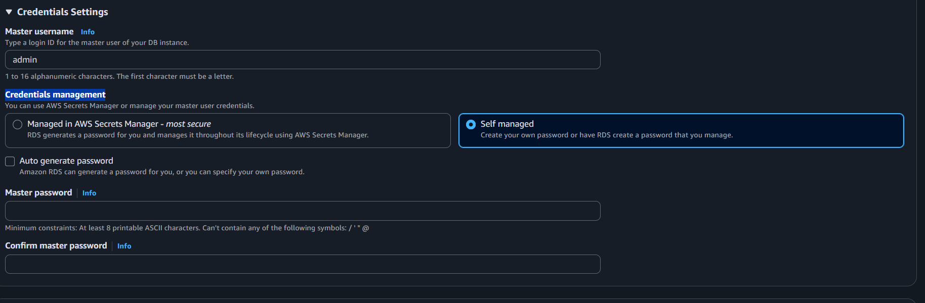

Instance configuration
Burstable classes
db.t4g.micro or db.t3.micro

Storage
Storage type: default
Allocated storage: default

Connectivity
Don’t connect to an EC2 compute resource
IPv4
Virtual private cloud (VPC): choose the vpc you plan on using
DB subnet group: choose the rds-subnet-group
Public access: No
VPC security group (firewall): Choose existing
Existing VPC security groups: rds-lab-sg (get rid of the default option)
Everything you can leave as default
Click create database

Secret Manager
Secret Manager store a new secret
Choose secret type
Secret type: Credentials for Amazon RDS database
Credentials
Create both a user name and password (make sure password is strong)
Database: choose the database you created Next
Configure secret
Secret name and description
Secret name: lab/rds/mysql next

Then scroll down next review page click store

IAM
IAM Policies create policy
Click on the JSON tab
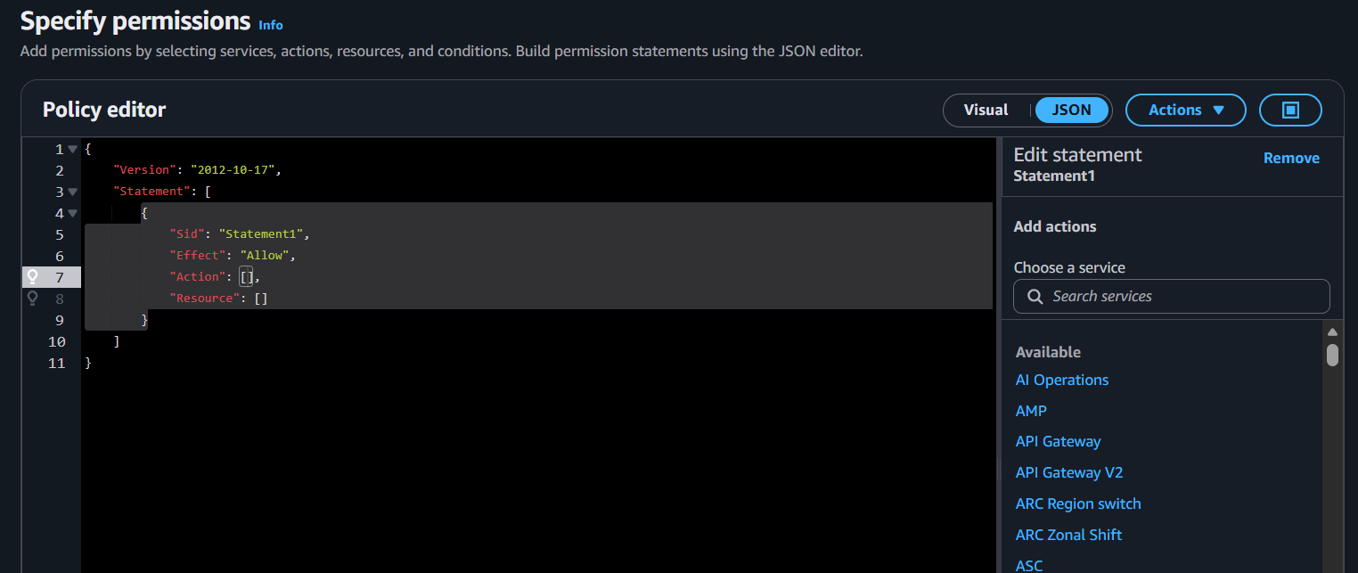
Use this line policy to replace the one the one above, replace the * with the secret ARN in Secret manager
Secret Manager Secrets Secret names

{
"Version": "2012-10-17",
"Statement": [
{
"Sid": "ReadSpecificSecret",
"Effect": "Allow",
"Action": [
"secretsmanager:GetSecretValue"
],
"Resource": "arn:aws:secretsmanager:us-west-2:950876749850:secret:lab/rds/mysql*"
}
]
}

Review and create
Policy details
Policy name: read-policy-secret create policy

IAM Roles Create role
Select Trusted entity
Trusted entity type: AWS service
Use case
Service or use case: EC2 EC2 Next
Add permissions
Permissions policies: in the search bar read-policy-secret check Next
Role details
Role name: ec2-get-secret-role create role
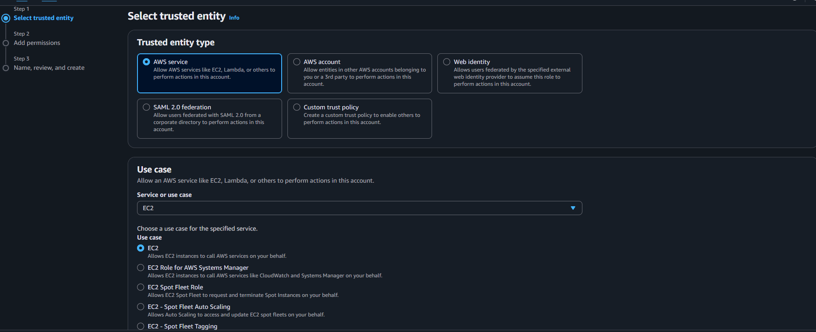
EC2
EC2 Instance Launch instances
Launch an instance
Name and tags: ec2-lab-app
AMI: Amazon Linux 2023
Instance type: t3.micro
Key pair: choose/create (for SSH)
Network Settings:
Edit
Choose created VPC
Choose the subnet (public)
Auto-assign public IP: Enable
Firewall: Select existing sg ec2-lab-sg
Advanced details
IAM instance profile: ec2-get-secret-role
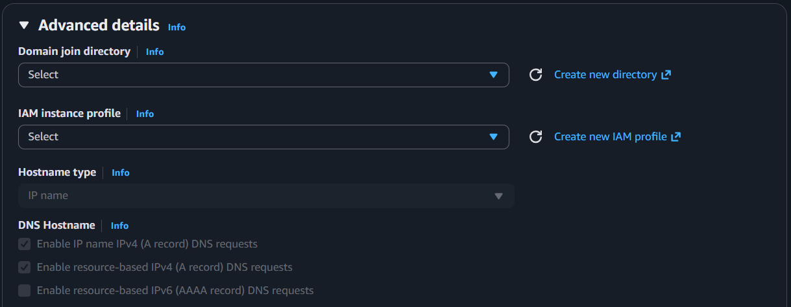

User data – optional
Click Launch instance
#!/bin/bash
dnf update -y
dnf install -y python3-pip
pip3 install flask pymysql boto3

mkdir -p /opt/rdsapp
cat >/opt/rdsapp/app.py <<'PY'
import json
import os
import boto3
import pymysql
from flask import Flask, request

REGION = os.environ.get("AWS_REGION", "us-west-2")
SECRET_ID = os.environ.get("SECRET_ID", "lab/rds1/mysql")

secrets = boto3.client("secretsmanager", region_name=REGION)

def get_db_creds():
resp = secrets.get_secret_value(SecretId=SECRET_ID)
s = json.loads(resp["SecretString"])
# When you use "Credentials for RDS database", AWS usually stores:
# username, password, host, port, dbname (sometimes)
return s

def get_conn():
c = get_db_creds()
host = c["host"]
user = c["username"]
password = c["password"]
port = int(c.get("port", 3306))
db = c.get("dbname", "labdb") # we'll create this if it doesn't exist
return pymysql.connect(host=host, user=user, password=password, port=port, database=db, autocommit=True)

app = Flask(__name__)

@app.route("/")
def home():
return """
<h2>EC2 → RDS Notes App</h2>
<p>POST /add?note=hello</p>
<p>GET /list</p>
"""

@app.route("/init")
def init_db():
c = get_db_creds()
host = c["host"]
user = c["username"]
password = c["password"]
port = int(c.get("port", 3306))

# connect without specifying a DB first
conn = pymysql.connect(host=host, user=user, password=password, port=port, autocommit=True)
cur = conn.cursor()
cur.execute("CREATE DATABASE IF NOT EXISTS labdb;")
cur.execute("USE labdb;")
cur.execute("""
CREATE TABLE IF NOT EXISTS notes (
id INT AUTO_INCREMENT PRIMARY KEY,
note VARCHAR(255) NOT NULL
);
""")
cur.close()
conn.close()
return "Initialized labdb + notes table."

@app.route("/add", methods=["POST", "GET"])
def add_note():
note = request.args.get("note", "").strip()
if not note:
return "Missing note param. Try: /add?note=hello", 400
conn = get_conn()
cur = conn.cursor()
cur.execute("INSERT INTO notes(note) VALUES(%s);", (note,))
cur.close()
conn.close()
return f"Inserted note: {note}"

@app.route("/list")
def list_notes():
conn = get_conn()
cur = conn.cursor()
cur.execute("SELECT id, note FROM notes ORDER BY id DESC;")
rows = cur.fetchall()
cur.close()
conn.close()
out = "<h3>Notes</h3><ul>"
for r in rows:
out += f"<li>{r[0]}: {r[1]}</li>"
out += "</ul>"
return out

if __name__ == "__main__":
app.run(host="0.0.0.0", port=80)
PY

cat >/etc/systemd/system/rdsapp.service <<'SERVICE'
[Unit]
Description=EC2 to RDS Notes App
After=network.target

[Service]
WorkingDirectory=/opt/rdsapp
Environment=SECRET_ID=lab/rds1/mysql
Environment=AWS_REGION=us-west-2
Environment=AWS_DEFAULT_REGION=us-west-2
ExecStart=/usr/bin/python3 /opt/rdsapp/app.py
Restart=always

[Install]
WantedBy=multi-user.target
SERVICE

systemctl daemon-reload
systemctl enable rdsapp
systemctl start rdsapp

REGION = your Region,
SECRET ID = your Secret ID
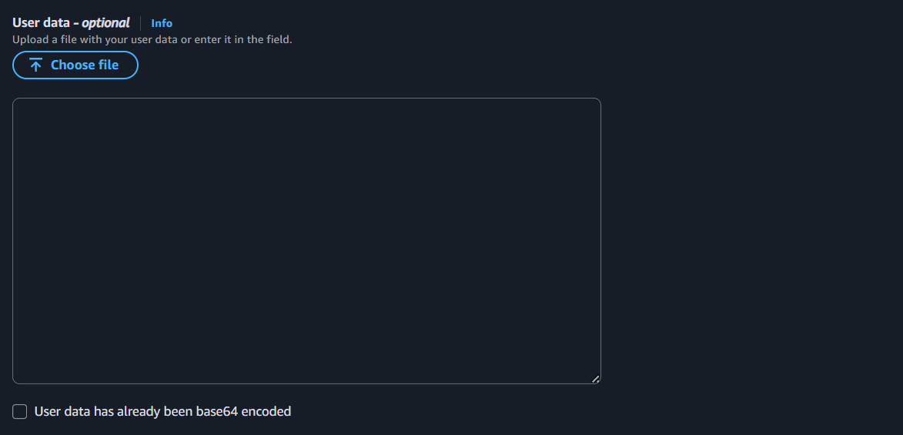
Attach role to EC2: EC2 Instance check mark instance Actions Security -- > Modify IAM role select your role

Open browser:
http://<EC2_PUBLIC_IP>
http://<EC2_PUBLIC_IP>/init
http://<EC2_PUBLIC_IP>/add?note=first_note
http://<EC2_PUBLIC_IP>/list

If /init hangs or error
Check RDS SG inbound not allowing from EC2 SG on 3306
RDS not in the same VPC/subnet
EC2 role missing secretmanager: GetSecretValue

